Orthogonal

* Mostly independent
* Our recipe has orthogonality meaning the same recipe can be used in different kinds of data

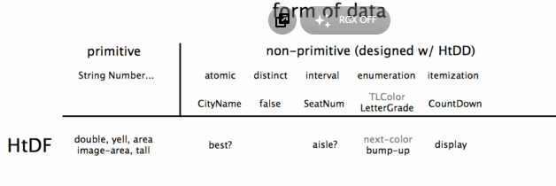

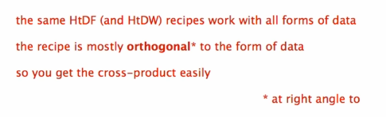

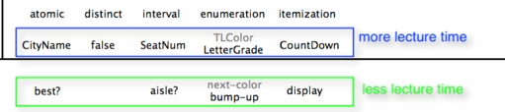

Future form of data that we will tackle on the other lectures

